Lab 5: Class Diagram
OBJECTIVE
The aim of this lab is to introduce students to the concept of UML class diagrams. Scenario shall be given to the user for which they shall have to create a class diagram.
SUBMISSION REQUIREMENT
You are expected to complete the assigned tasks within the lab session and show them to the lab engineer/instructor. Your labs will not be graded unless shown to the lab instructor in time (at least 10 min before end of lab session).
CLASS DIAGRAM
Class diagram in the Unified Modeling Language (UML) is a type of static structure diagram that describes the structure of a system by showing the system's classes, their attributes, operations (or) methods and the relationships between the classes.
The class diagram is used both for general conceptual modeling of the systematic of the application, and for detailed modeling translating the models into programming code. The classes in a class diagram represent both the main objects and or interactions in the application and the objects to be programmed. In the class diagram these classes are represented with boxes which contain three parts:
A class with three sections:
* The upper part holds the name of the class
* The middle part contains the attributes of the class
* The bottom part gives the methods or operations the class can take or undertake
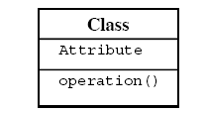
For Example:
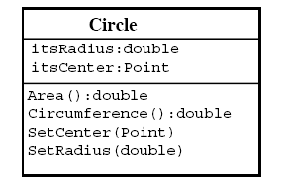
Composition Relationships
Each instance of type Circle seems to contain an instance of type Point. This is a relationship known as composition. It can be depicted in UML using a class relationship.
The black diamond represents composition. It is placed on the Circle class because it is the Circle that is composed of a Point. The arrowhead on the other end of the relationship denotes that the relationship is navigable in only one direction. That is, Point does not know about Circle. In UML relationships are presumed to be bidirectional unless the arrowhead is present to restrict them. If the arrowhead is omitted, it would have meant that Point knew about Circle. At the code level, this would imply a #include “circle.h” within point.h.
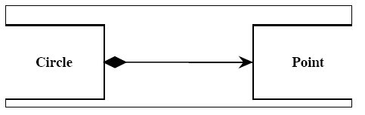
Composition relationships are a strong form of containment or aggregation. Aggregation is a whole/part relationship. In this case, Circle is the whole, and Point is part of Circle. Composition also indicates that the lifetime of Point is dependent upon Circle. This means that if Circle is destroyed, Point will be destroyed with it.
Inheritance
The inheritance relationship in UML is depicted by a peculiar triangular arrowhead. This arrowhead that looks rather like a slice of pizza, points to the base class. One or more lines proceed from the base of the arrowhead connecting it to the derived classes.
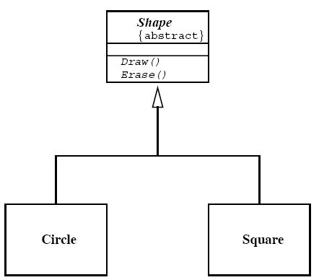
Figure shows the form of the inheritance relationship. In this diagram we see that Circle and Square both derive from Shape. Note that the name of class Shape is shown in italics. This indicates that Shape is an abstract class. Note also that the operations, Draw () and Erase () are also shown in italics. This indicates that they are pure virtual.
Aggregation / Association
The weak form of aggregation is denoted with an open diamond. This relationship denotes that the aggregate class (the class with the white diamond touching it) is in some way the “whole”, and the other class in the relationship is somehow “part” of that whole.
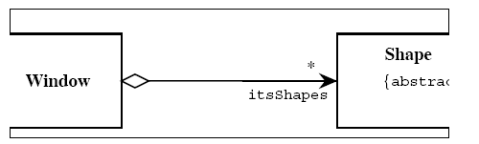
Interfaces
There are classes that have nothing but pure virtual functions. In Java such entities are not classes at all; they are a special language element called an interface. UML has followed the Java example and has created some special syntactic elements for such entities.
The primary icon for an interface is just like a class except that it has a special denotation called a stereotype.
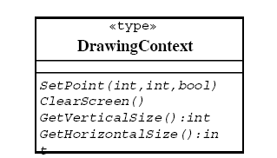
Alternate representation is the lollipop representation:
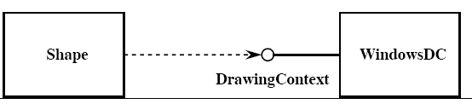
TASK
Create a class diagram for Next Generation Point of Sale Application.
The Domain Model is given below:
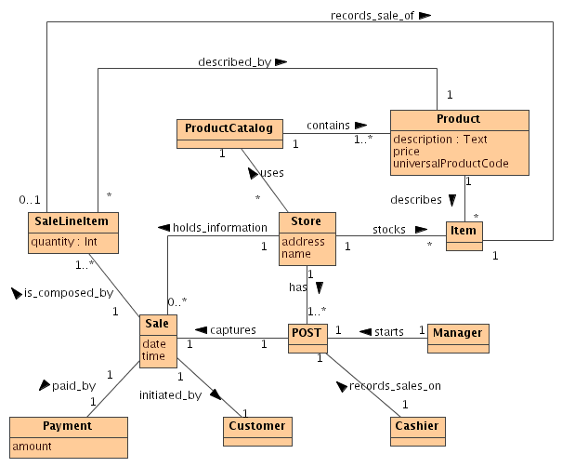
Reference: Applying UML and Patterns by Craig Larmen (Ch#12, Ch#16)

